**Windows Server data deduplication**

Tested OS: Windows Server 2019

Tested FS: ReFS (26GB of ISO and video data)

Install dedup feature: Install-WindowsFeature FS-Data-Deduplication

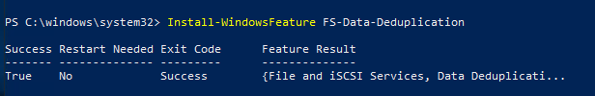

DDPEval.exe – used to evaluate the storage saving you would get by enabling data deduplication on a volume.

Scan volume D:\ ddpeval.exe D:\ /P

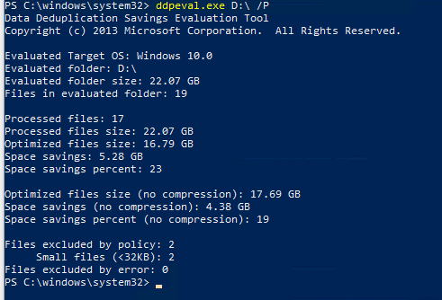

Data deduplication also has a Powershell module

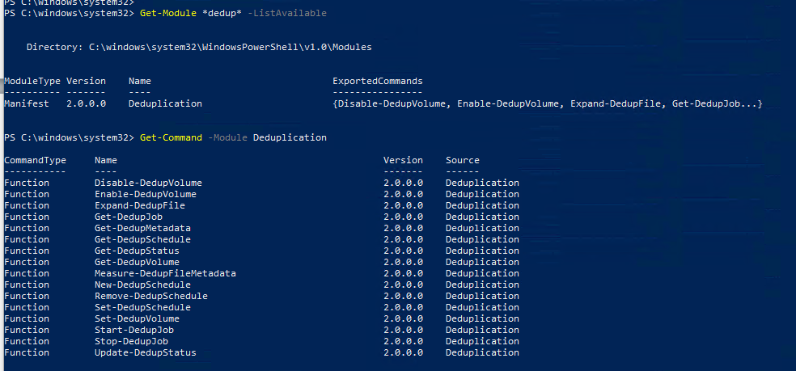

Data deduplication can be configured by right clicking on the desired volume in server manager

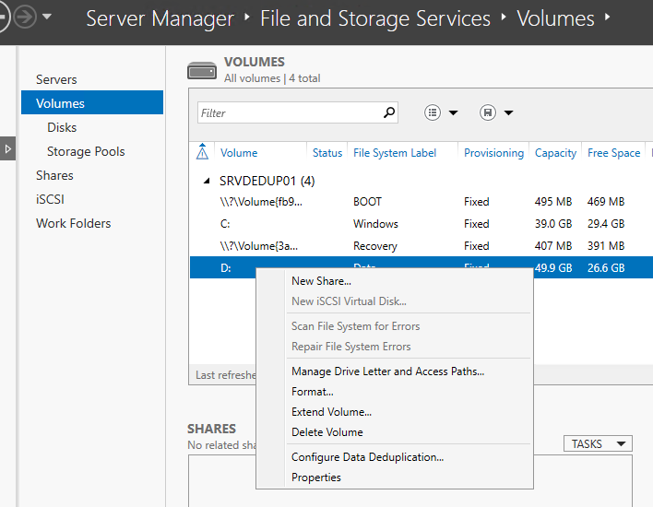

The 3 types of dedup

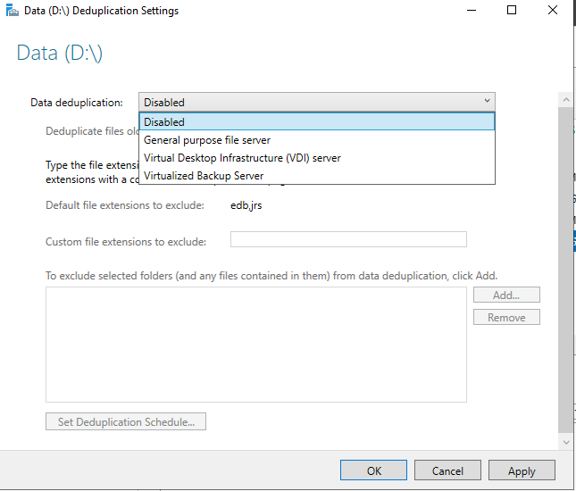

To enable use:

Enable-DedupVolume -Volume D:\ -UsageType Default

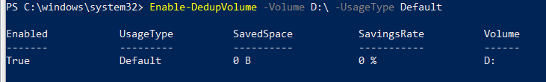

Data dedup schedule settings

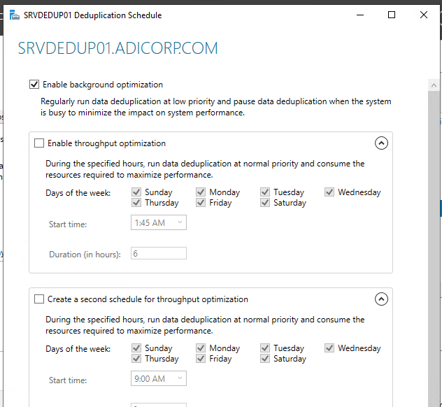

Set the file age: Set-DedupVolume -Volume D: -MinimumFileAgeDays 1

This will dedup files older than 1 day. Set to 0 to dedup any file on the volume at the time the job runs.

Scheduled tasks:

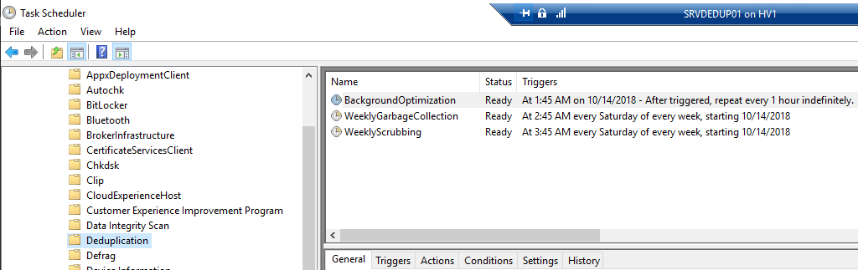

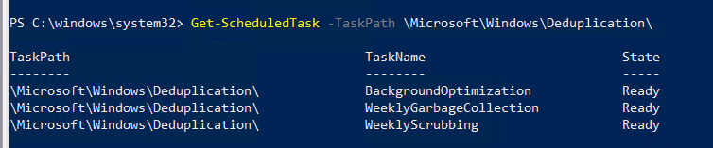

Start-ScheduledTask -TaskPath \Microsoft\Windows\Deduplication\ -TaskName BackgroundOptimization

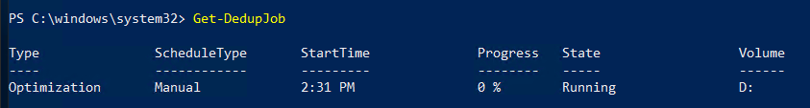

Wait some time and then check the volume free space.

